Optimizing Email Frequency and Personalizing Department Recommendations for IKEA
A Group Assignment in Marketing Analytics

Vy (Valerie) Mai Le, Annie Tran, Lina Slaoui, & Jun Wen
DePauw University

BUS 390B: Marketing Analytics
Professor Ehsan Saremi
December 8, 2025

Google Colab Notebook: IKEA_Assignment5_GroupCode.ipyb
Part 1: Email Frequency
ikea.ipynb
- Understanding the patterns
When IKEA sends more emails, customers think about the brand more often, which encourages them to look at products and make purchases. People who stay subscribed are usually the ones who already like IKEA and are more interested in buying, so their spending increases with more emails. Customers who unsubscribe may still buy things before they opt out, because earlier emails reminded them of products they need. Even after unsubscribing, some customers continue to shop at IKEA, and the ideas they saw in past emails can still influence their choices. These reasons explain why both groups spend more when email frequency increases.

- Compute six-month LTV - calculation shown in the Colab file
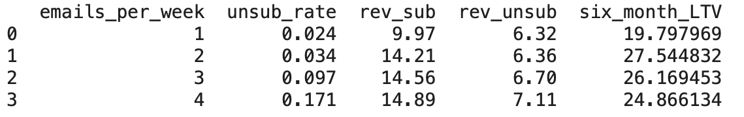

- Recommend a single email-frequency policy
Based on the six-month LTV results, IKEA should send 2 emails per week to all online customers. This frequency creates the highest LTV ($27.54) compared to 1, 3, or 4 emails per week. While sending more emails increases short-term revenue, it also leads to higher unsubscribe rates. At 3 and 4 emails per week, the unsubscribe rate becomes too high, which lowers long-term value.
Sending only 1 email per week reduces the unsubscribe rate, but it also limits sales and produces a much lower LTV. Therefore, 2 emails per week offers the best balance between customer engagement and retention, giving IKEA the strongest long-run financial outcome.

Part 2: What Should Each Customer’s Email Focus On?
From Randomness to Personalization
After running logit models to get the customer’s predicted probabilities for each possible department, we assign each customer the “best department” associated with their highest predicted probability. Below is a summary of the percentage of customers for whom each department produced the highest predicted purchase probability:
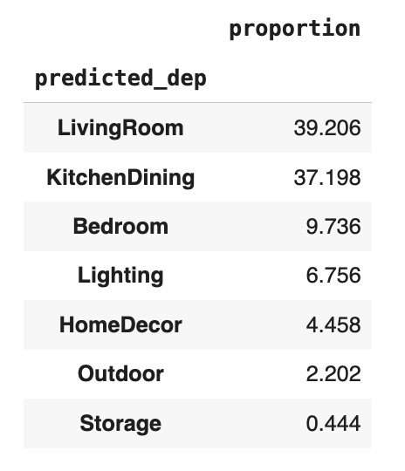
We continue to extend our analysis from purchase likelihood to profitability by identifying each customer’s “best department” based on the highest predicted profit out of each possible department. We calculate the profit margin for each department using the department’s average order size. Below is a summary of the percentage of customers for whom each department produced the highest predicted profit:
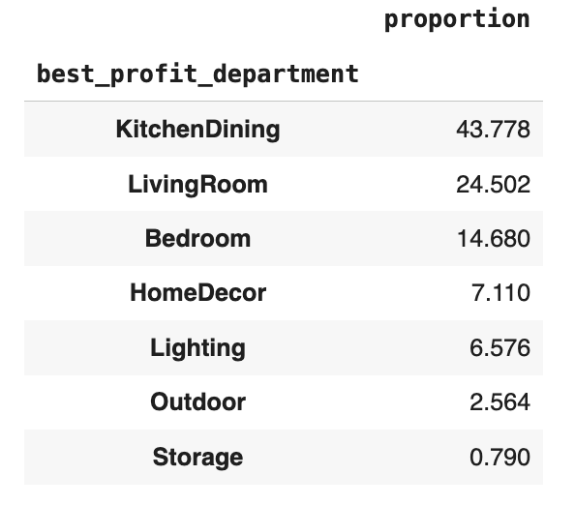
There are differences between distributions of best departments based on probability vs. profit. Firstly, Kitchen Dining has the largest distribution based on profit, while Living Room has the largest distribution based on probability. Secondly, Living Room's proportion decreased by nearly half when distributed based on profit, which indicates that while it is more likely for people to purchase something from the Living Room department, it generates less profit. Thirdly, Home Decor is more recommended over Lighting based on profit, but not based on probability. And finally, the only similarity between the distributions was that the last two departments, Outdoor and Storage, consistently have the lowest distributions.

Q5-Average Expected Profit Under Personalization
The evaluation of personalization benefits required us to determine expected customer profits through IKEA department email selection based on individual profit maximization. The profit calculation depends on department purchase probability forecasts and their corresponding average transaction amounts. The personalized strategy selects for each customer the department which produces the highest expected profit and we calculate the average of these maximum values across all validation set customers. The results demonstrate that personalization produces an average expected profit of $2.044 per customer which makes it the most profitable strategy.
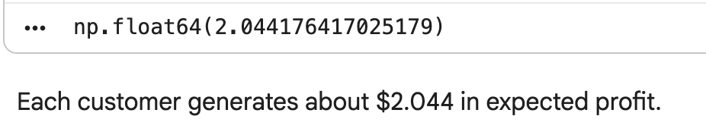
Q-6 Average Expected Profit Under a One-Size-Fits-All Strategy
The research examined IKEA's performance when using a single department message for all customers. The average expected profit for each department emerged from calculating the mean expected profit value in each department's column. The Kitchen Dining department produces the highest profit from a single department strategy because it generates $1.914 per customer which surpasses the performance of Living Room and Lighting and Outdoor and Storage departments. The uniform strategy produces acceptable results but it generates lower profits than the customized solution presented in Question 5.
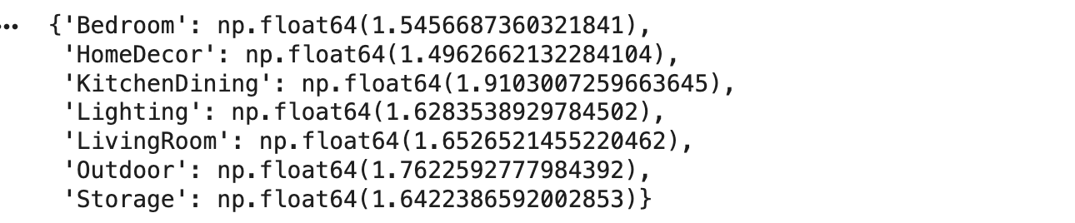
Q-7 Expected Profit Under Random Assignment
The random assignment method which duplicates IKEA's current department email rotation system gives each customer equal chances to obtain any of the seven available department emails. The calculation involved taking the average of each customer's seven expected profit values before finding the average value across all customers. The random assignment method produces an expected profit of $1.663 per customer which turns out to be the worst result among the three tested approaches. The baseline value for comparison purposes will be this number to evaluate personalization effectiveness.
Q-8 Improvement from Personalization vs. Random Assignment
The financial benefits of personalized strategies against random department assignments became measurable through our comparison between Question 5 and Question 7. The personalized approach leads to a 22.96% profit boost which raises the average customer value from $1.663 to $2.044. The national email campaign which reaches 10 million customers would experience a profit boost of approximately $3.82 million when using personalized department assignments. The results show that personalized department assignments generate significantly more revenue than random department assignments.

Part 3: Should IKEA implement the proposed policy by Sara?
- Should IKEA implement this policy?
Yes, IKEA should implement Sara’s proposed policy, but in a phased and monitored way. Our analysis in Parts 1 and 2 shows that combining an optimal email frequency of two emails per week with model-based, profit-focused personalization creates meaningful financial upside while improving the customer experience. At the same time, IKEA should treat this as a “test-and-learn” system rather than a fixed rule, with strong safeguards around model performance, customer privacy, and email fatigue.

- Why the policy is likely to succeed
- Stronger long-run value from frequency choice
The LTV analysis in Part 1 shows that sending two emails per week generates the highest six-month LTV (about $27.54), outperforming 1, 3, and 4 emails. Higher frequencies raise short-term revenue, but the steep jump in unsubscribe rates at 3 and 4 emails erodes long-term value. At two emails per week, IKEA stays “top of mind” without pushing customers to opt out, which protects the ability to market future campaigns over time.

- Personalization materially improves profit versus random rotation
Under random department assignment, the expected profit is about $1.66 per customer, while a fully personalized policy that chooses the highest-profit department for each individual raises this to about $2.04 per customer — a lift of roughly 23%. For a national campaign to 10 million customers, this translates into about $3.8 million in incremental profit compared to random assignment. Even compared with the best one-size-fits-all option (always sending Kitchen Dining, about $1.91 per customer), personalization still delivers higher returns. This shows that using the Next Product to Buy model to tailor messages is not just statistically interesting; it creates real, scalable economic value.

- More relevant customer experience
The proposed policy also improves the quality of communication from the customer’s point of view. Instead of a random “department of the week,” customers would receive emails that align more closely with their demonstrated interests (e.g., high space-optimization index → storage-oriented content; high home-improvement index → departments with larger projects). This relevance should increase engagement and reduce the frustration that comes from irrelevant promotions, which in turn supports lower unsubscribe rates and stronger brand equity.

- Better internal alignment around value, not internal politics
Historically, each department optimized its own email volume and content, creating clutter and internal conflict. The new policy gives everyone a shared, transparent rule: the “winning” department for a customer is whichever email is predicted to generate the most profit, not whichever team shouts loudest. That helps IKEA move from fragmented, department-centric emailing to a company-wide, profit-centric approach.

- Risks and weaknesses of the policy
Even though the policy is attractive, it has several risks that IKEA should manage carefully.
- Model risk and data drift
The NPTB models are trained on historical data with oversampled buyers and then corrected back to the true response rate of 0.84%. If customer behavior changes (new product lines, macroeconomic shocks, different promotional calendars), the models could become less accurate over time. A static model could start sending the “wrong” department to large segments of customers, hurting both revenue and trust.
- Over-optimization on the short term
Because the policy is based on expected profit, it naturally favors departments like Kitchen Dining that have higher average order sizes and profit per response. That is good for near-term margins, but it may crowd out categories that matter for long-term customer relationships or strategic priorities (for example, lower-ticket decor items that keep people engaged between big purchases). A purely profit-maximizing rule can unintentionally narrow IKEA’s perceived assortment.

- Customer perception and privacy concerns
Highly personalized emails can feel “creepy” if not communicated well. If customers sense that IKEA is using detailed behavioral profiles without transparency, they may worry about data usage or tracking, which could increase unsubscribes and damage brand trust, especially in European markets with strong privacy norms and regulations.

- Operational complexity and dependence on analytics
Implementing this policy requires reliable data pipelines, regular model retraining, monitoring, and coordination across seven departments. If the infrastructure is weak or teams do not trust the model, the policy may fail in practice even if it is sound on paper.

- How the policy should be improved
To make the policy more robust and sustainable, IKEA should begin by rolling it out in phases with continuous testing. A controlled pilot using a subset of markets or customers and comparing three groups (personalization, the best one-size-fits-all department, and a holdout control group) would allow IKEA to measure the true lift from personalization before committing to a full-scale launch. This step preserves experimentation and ensures that decisions are guided by real performance rather than assumptions.
IKEA should also maintain strong guardrails on email volume and customer experience. Keeping the frequency capped at two emails per week remains important, as it minimizes fatigue while still supporting meaningful engagement. Throughout the rollout, IKEA should monitor unsubscribe rates, complaint patterns, open rates, and click-through behavior across different customer segments. If certain groups show early signs of overload, the company can reduce frequency for those segments or introduce scheduled quiet periods to prevent burnout.
Another essential component is ensuring that the predictive models remain accurate and transparent. Because customer behavior evolves over time, IKEA should regularly refresh the logistic models with new data, audit model calibration by comparing predicted and actual response rates, and examine which features are driving departmental recommendations. These practices help detect model drift and unintended biases early, and they build trust among internal teams that rely on the system.
IKEA should also balance the model’s profit-focused output with broader strategic and brand objectives. While the profit model identifies the most financially advantageous department for each customer, the company may not want to rely solely on algorithmic optimization. Incorporating business rules, such as ensuring periodic exposure for new product lines, seasonal promotions, or strategic priorities, allows IKEA to retain assortment visibility and support long-term brand positioning while still leveraging the benefits of personalization.
Finally, IKEA should communicate personalization as a customer benefit rather than a form of surveillance. The company can highlight that customers will now receive fewer, more relevant emails and provide them with easy tools to set or change their preferences. Clear communication, paired with transparency about why they are receiving certain messages, will help reduce privacy concerns and strengthen long-term trust in IKEA’s digital experience.

Conclusion
Overall, the evidence from our analysis supports implementing Sara’s policy of optimized email frequency and model-based personalization, with careful execution. The approach increases profit per customer, scales to millions of online shoppers, and improves message relevance compared with both random assignment and a single generic email. If IKEA treats this as an evolving, data-driven system, rather than a one-time solution, and invests in monitoring, transparency, and customer control, the policy is likely to succeed and become a durable advantage for IKEA’s digital marketing strategy.

